ERGO3 Virtual Globetrotter
Installation Guide
Configuring Windows Defender Firewall
We need to configure the Firewall, because by default Windows does not let programs receive data over the network. In this step, we are going to open two ports to listen for incoming data, so we can receive the AI generated images to be displayed in the Immersive Room.
If You are running the program on the Immersive Room computer, this step should already be completed.
- Navigate to the Start Menu.
- Type “Windows Defender Firewall with Advanced Security” in the search box, and click on the first result.
- Click on “Inbound rules”, then press the “New Rule…” button
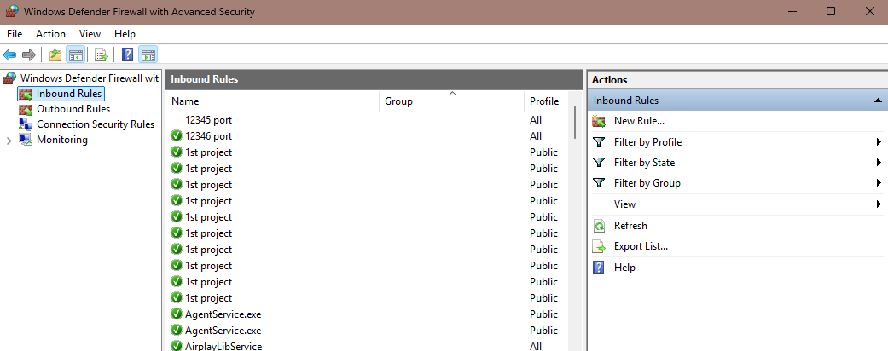
- Select “Port”, then click “Next >”
- Select “TCP”, and “Specific local ports”, then enter this: “12345, 12346” in the dialog box.
- Click “Next >” until You have to name the rule.
- Pick a memorable name (We used “12345 port”), but You can name it however You want to.
- You can now safely close the application.

Getting the Immersive Room computer’s IP address
We need to know the computer’s IP address to send images to it. Follow these steps on the computer that is connected to the Immersive Room.
- Navigate to the Start Menu.
- Type “cmd” in the Search Box, and click on the first result.
- Now, type “ipconfig” in the program, and press Enter.
- You should see something like this: 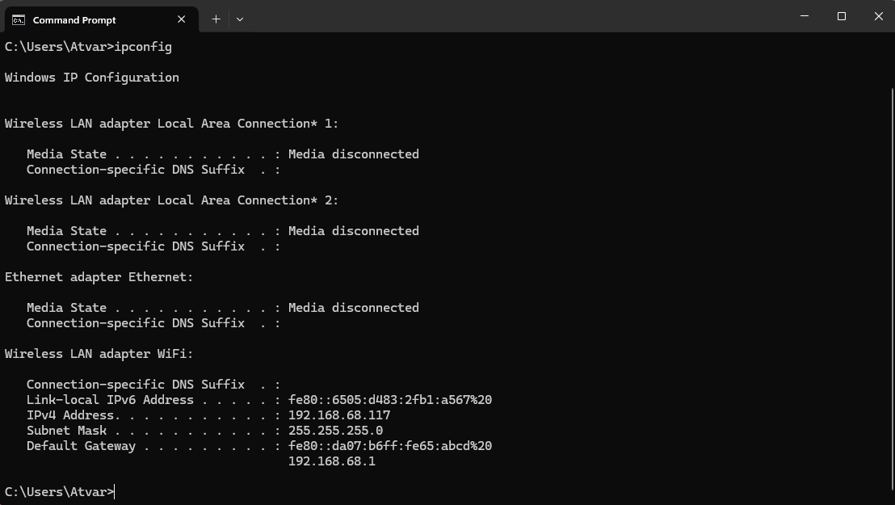
- Note the string of numbers on the “IPv4 Address” line, and paste it in the VIOLA, FINISH THIS
Running the Project
If You have followed the previous steps, You can now safely run the project, by double-clicking on the .exe file. Follow the steps below on the Immersive Room computer.
- Open the “ERGO3_Virtual_Globetrotter” folder.
- Double-click on the “Virtual Globetrotter.exe” file (It should have an icon of a blue MCT robot).

(Optional) Installing Unity
To change either the Slideshow Images, or the Background Music, You need to open the project through Unity.
This project was developed using Unity version 6000.0.25f1, we recommend You install the same, or similar version.
To download Unity, You first need to visit the website:
https://public-cdn.cloud.unity3d.com/hub/prod/UnityHubSetup.exe
Follow the steps in the Install Wizard, and then open the Unity Hub, which should look something like this:
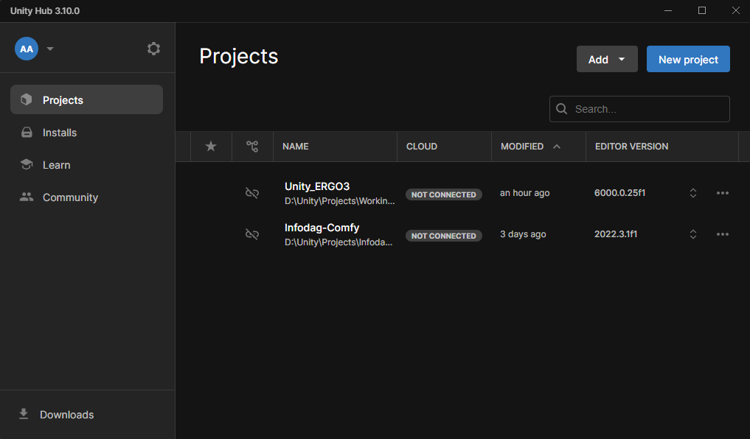
Click on “Add”, then select “Add project from disk”.
A Windows File Explorer window will open. You now need to navigate to the folder “Unity_ERGO3”. Click on it once (just select it, don’t open it), and press the “Add Project” button in the bottom-right corner.
It should now show up in the “Projects” tab in Unity Hub. You can click on it to open the project in Unity.
To change images or music, follow the steps in the User Manual.

